

TEST PLAN

<<Guru99 Bank>

Abstract

This document provides an overview of the project and the product test strategy, a list of testing deliverables and plan for development

Krishna Rungta

[support@guru99.com]

Private & Confidential
Guru99 Banking Testing Project

VERSION HISTORY

 | Version |  | Write by |  | Revision |  |  | Approved |  |  | Approval |  | Outline
 | # |  |  |  | Date |  |  | By |  |  | Date
1.0 |  |  | Krishna Rungta | 2018/12/12 |  |  | Peter |  |  | 2018/12/24 |  |  | Test Plan create

Page 2 of 9

Private & Confidential
Guru99 Banking Testing Project

TABLE OF CONTENTS

INTRODUCTION ..................................................................................................................... |  |  | 4
1 | TEST STRATEGY ................................................................................................................. |  | 4
 | 1.1 | Test Type ................................................................................................................... | 5
 | 1.2 | Scope of Testing ........................................................................................................ | 4
 |  | 1.2.1 Feature to be tested ............................................................................................ | 4
 |  | 1.2.2 Feature not to be tested ...................................................................................... | 5
 | 1.3 | Risk and Issues ........................................................................................................... | 5
 | 1.4 | Test Logistics.............................................................................................................. | 6
 |  | 1.4.1 Who will test? ...................................................................................................... | 6
 |  | 1.4.2 When will test occur? .......................................................................................... | 6
2 | TEST OBJECTIVE ................................................................................................................ |  | 6
3 | TEST CRITERIA ................................................................................................................... |  | 6
 | 3.1 | Suspension Criteria .................................................................................................... | 6
 | 3.2 | Exit Criteria ................................................................................................................ | 6
4 | RESOURCE PLANNING ....................................................................................................... |  | 6
 | 4.1 | System Resource ....................................................................................................... | 6
 | 4.2 | Human Resource ....................................................................................................... | 7
5 | TEST ENVIRONMENT ......................................................................................................... |  | 7
6 | SCHEDULE & ESTIMATION ................................................................................................. |  | 8
 | 6.1 | All project task and estimation ................................................................................. | 8
 | 6.2 | Schedule to complete these tasks ............................................................................. | 9
7 | TEST DELIVERABLES ........................................................................................................... |  | 9
 | 7.1 | Before testing phase ................................................................................................. | 9
 | 7.2 | During the testing ...................................................................................................... | 9
 | 7.3 | After the testing cycles is over .................................................................................. | 9

Page 3 of 9

Private & Confidential
Guru99 Banking Testing Project

INTRODUCTION

The Test Plan is designed to prescribe the scope, approach, resources, and schedule of all testing activities of the project Guru99 Bank.

The plan identify the items to be tested, the features to be tested, the types of testing to be performed, the personnel responsible for testing, the resources and schedule required to complete testing, and the risks associated with the plan.

1 TEST STRATEGY

1.1 Scope of Testing

1.1.1 Feature to be tested

All the feature of websiteGuru99 Bank which were defined in software requirement specs are need to bested

 | Module Name |  |  | Applicable |  |  | Description
 |  |  |  | Roles
 | Balance |  |  | Manager |  |  | Customer: A customer can have multiple bank accounts. He can
 | Enquiry |  |  | Customer |  |  | view balance of his accounts only
 |  |  |  |  |  |  | Manager: A manager can view balance of all the customers who
 |  |  |  |  |  |  | come under his supervision
 | Fund Transfer |  |  | Manager |  |  | Customer: A customer can have transfer funds from his “own”
 |  |  |  | Customer |  |  | account to any destination account.
 |  |  |  |  |  |  | Manager: A manager can transfer funds from any source bank
 |  |  |  |  |  |  | account to destination account
 | Mini Statement |  |  | Manager |  |  | A Mini statement will show last 5 transactions of an account
 |  |  |  | Customer |  |  | Customer: A customer can see mini-statement of only his “own”
 |  |  |  |  |  |  | accounts
 |  |  |  |  |  |  | Manager: A manager can see mini-statement of any account
 | Customized |  |  | Manager |  |  | A customized statement allows you to filter and display
 | Statement |  |  | Customer |  |  | transactions in an account based on date, transaction value
 |  |  |  |  |  |  | Customer: A customer can see Customized- statement of only
 |  |  |  |  |  |  | his “own” accounts
 |  |  |  |  |  |  | Manager: A manager can see Customized -statement of any
 |  |  |  |  |  |  | account
 | Change |  |  | Manager |  |  | Customer: A customer can change password of only his account.
 | Password |  |  | Customer |  |  | Manager: A manager can change password of only his account.
 |  |  |  |  |  |  | He cannot change passwords of his customers
 | New Customer |  |  | Manager |  |  | Manager: A manager can add a new customer.
 |  |  |  | Manager |  |  | Manager: A manager can edit details like address, email,
 |  |  |  |  |  |  | telephone of a customer.
 | New Account |  |  | Manager |  |  | Currently system provides 2 types of accounts
 |  |  |  |  |  |  | • | Saving
 |  |  |  |  |  |  | • | Current
 |  |  |  |  |  |  | A customer can have multiple saving accounts (one in his name,
 |  |  |  |  |  |  | other in a joint name etc).
 |  |  |  |  |  |  |  | Page 4 of 9
 |  |  |  |  |  |  |  | Private & Confidential

Guru99 Banking Testing Project

 |  | He can have multiple current accounts for different companies
 |  | he owns.
 |  | Or he can have a multiple current and saving accounts.
 |  | Manager: A manager can add a new account for an existing
 |  | customer.
Edit Account | Manager | Manager: A manager can add a edit account details for an
 |  | existing account
Delete Account | Manager | Manager: A manager can add a delete an account for a
 |  | customer.
Delete | Manager | A customer can be deleted only if he/she has no active current
Customer |  | or saving accounts
 |  | Manager: A manager can delete a customer.
Deposit | Manager | Manager: A manager can deposit money into any account.
 |  | Usually done when cash is deposited at a bank branch.
Withdrawal | Manager | Manager: A manager can withdraw money from any account.
 |  | Usually done when cash is withdrawn at a bank branch.

1.1.2 Feature not to be tested

These feature are not be tested because they are not included in the software requirement specs

- User Interfaces

- Hardware Interfaces

- Software Interfaces

- Database logical

- Communications Interfaces

- Website Security and Performance

1.2 Test Type

In the project Guru99 Bank, there’re 3 types of testing should be conducted.

- Integration Testing (Individual software modules are combined and tested as a group)

  - System Testing: Conducted on a complete, integrated system to evaluate the system's compliance with its specified requirements

  - API testing: Test all the APIs create for the software under tested

1.3 Risk and Issues

 | Risk |  |  | Mitigation
 | Team member lack the required skills for |  |  | Plan training course to skill up your members
 | website testing.
 | The project schedule is too tight; it's hard to |  |  | Set Test Priority for each of the test activity.
 | complete this project on time
 | Test Manager has poor management skill |  |  | Plan leadership training for manager

Page 5 of 9

Private & Confidential
Guru99 Banking Testing Project

 | A lack of cooperation negatively affects your | Encourage each team member in his task, and
 | employees' productivity | inspire them to greater efforts.
 | Wrong budget estimate and cost overruns | Establish the scope before beginning work, pay
 |  | a lot of attention to project planning and
 |  | constantly track and measure the progress
1.4 Test Logistics
1.4.1 Who will test?

The project should use outsource members as the tester to save the project cost

1.4.2 When will test occur?

The tester will start the test execution when all the following inputs are ready

- Software is available for testing

- Test Specification is created

- Test Environment is built

- Enough human resource for testing

2 TEST OBJECTIVE

The test objectives are to verify the Functionality of website Guru99 Bank, the project should focus on testing the banking operation such as Account Management, Withdrawal, and Balance…etc. to guarantee all these operation can work normally in real business environment.

3 TEST CRITERIA

3.1 Suspension Criteria

If the team members report that there are 40% of test cases failed, suspend testing until the development team fixes all the failed cases.

3.2 Exit Criteria

Specifies the criteria that denote a successful completion of a test phase

- Run rate is mandatory to be 100% unless a clear reason is given.

- Pass rate is 80%, achieving the pass rate is mandatory.

4 RESOURCE PLANNING

 | 4.1 | System Resource
 | No. |  |  | Resources |  |  | Descriptions
 | 1. |  |  | Server |  |  | Need a Database server which install MySQL server
 |  |  |  |  |  |  | Web server which install Apache Server
 |  |  |  |  |  |  | Page 6 of 9
 |  |  |  |  |  |  | Private & Confidential

Guru99 Banking Testing Project

2. |  |  |  | Test tool |  |  | Develop a Test tool which can auto generate the test result to the pre-
 |  |  |  |  |  |  | defined form and automated test execution
3. |  |  |  | Network |  |  | Setup a LAN Gigabit and 1 internet line with the speed at least 5 Mb/s
4. |  |  |  | Computer |  |  | At least 4 computer run Windows 7, Ram 2GB, CPU 3.4GHZ
4.2 |  |  | Human Resource
No. |  |  |  | Member |  |  |  |  |  |  |  | Tasks
1. |  |  | Test Manager |  |  |  |  |  |  | Manage the whole project
 |  |  |  |  |  |  |  |  |  | Define project directions
 |  |  |  |  |  |  |  |  |  | Acquire appropriate resources
2. |  |  | Test |  |  |  |  |  |  | Identifying | and | describing | appropriate | test
 |  |  |  |  |  |  |  |  |  | techniques/tools/automation architecture
 |  |  |  |  |  |  |  |  |  | Verify and assess the Test Approach
 |  |  |  |  |  |  |  |  |  | Execute the tests, Log results, Report the defects.
 |  |  |  |  |  |  |  |  |  | Outsourced members
3. |  |  | Developer in Test |  |  |  |  |  |  | Implement the test cases, test program, test suite etc.
4. |  |  | Test Administrator |  |  |  |  |  |  | Builds up and ensures test environment and assets are managed
 |  |  |  |  |  |  |  |  |  | and maintained
 |  |  |  |  |  |  |  |  |  | Support Tester to use the test environment for test execution
5. |  |  | SQA members |  |  |  |  |  |  | Take in charge of quality assurance
 |  |  |  |  |  |  |  |  |  | Check to | confirm | whether the testing process is |  | meeting
 |  |  |  |  |  |  |  |  |  | specified requirements
5 | TEST ENVIRONMENT
The Test Environment should be setup as figure below

Page 7 of 9

Private & Confidential
Guru99 Banking Testing Project
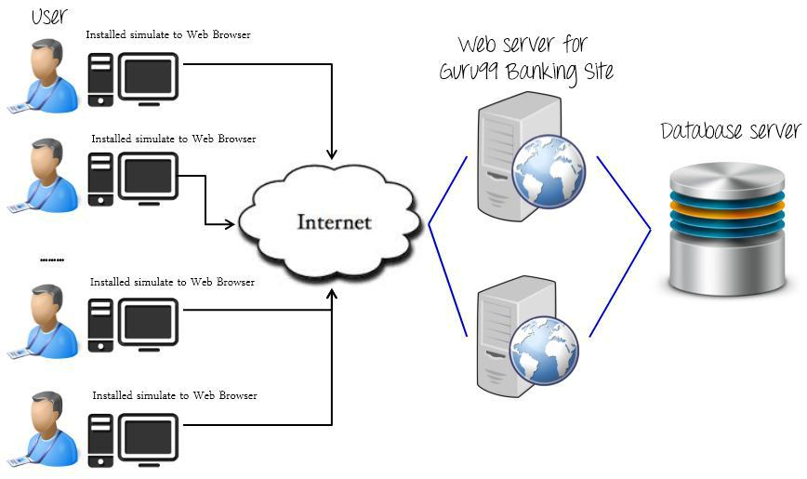

6 SCHEDULE & ESTIMATION

6.1 All project task and estimation

 | Task |  |  | Members |  |  | Estimate effort
 | Create the test |  |  | Test Designer |  |  | 170 man-hour
 | specification
 | Perform Test |  |  | Tester, Test Administrator |  |  | 80 man-hour
 | Execution
 | Test Report |  |  | Tester |  |  | 10 man-hour
 | Test Delivery |  |  |  |  |  | 20 man-hour
 | Total |  |  |  |  |  | 280 man-hour

Page 8 of 9

Private & Confidential
Guru99 Banking Testing Project

6.2 Schedule to complete these tasks
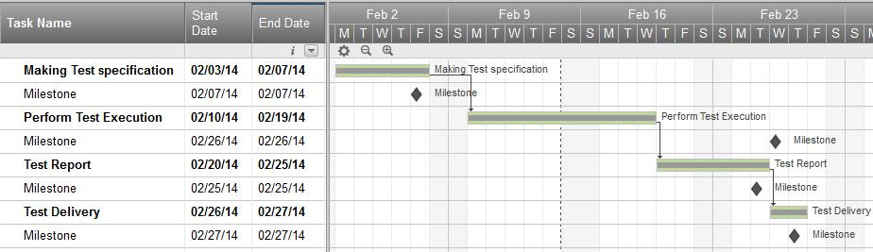

7 TEST DELIVERABLES

Test deliverables are provided as below

7.1 Before testing phase

- Test plans document.
- Test cases documents
- Test Design specifications.

7.2 During the testing

- Test Tool
- Simulators.
- Test Data
- Test Trace-ability Matrix
- Error logs and execution logs.

7.3 After the testing cycles is over

- Test Results/reports
- Defect Report

- Installation/ Test procedures guidelines
- Release notes

Page 9 of 9

Private & Confidential

